

FACULTY OF INFORMATION AND COMMUNICATION TECHNOLOGY

DCOMP204 – WEB DESIGN 1

Title : Individual Assignment
Issue Date : Week 4
Due Date : Week 7
Lecturer/Examiner : Mr. Amadu Kamara
Name of Student/s : SAMI BASSAM SKEIKY
Student ID No. : 905005439
Class : BIT 1103F
Year/Semester : 2/1

Academic Honesty Policy Statement

I/We, hereby attest those contents of this attachment are my own work. Referenced works, articles, art, programs, papers or parts thereof are acknowledged at the end of this paper. This includes data excerpted from CD-ROMs, the Internet, other private networks, and other people’s disk of the computer system.

Student’s Signature: Date:
LECTURER’S COMMMENTS/GRADE:

for office use only upon receive
Remark

DATE:
TIME:
RECEIVER’S NAME:

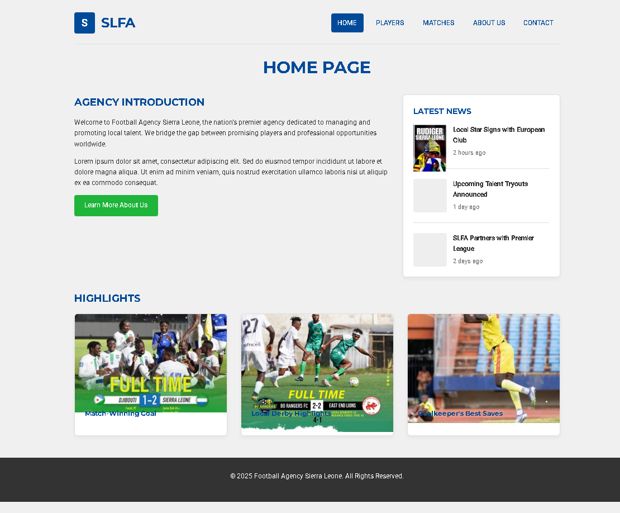

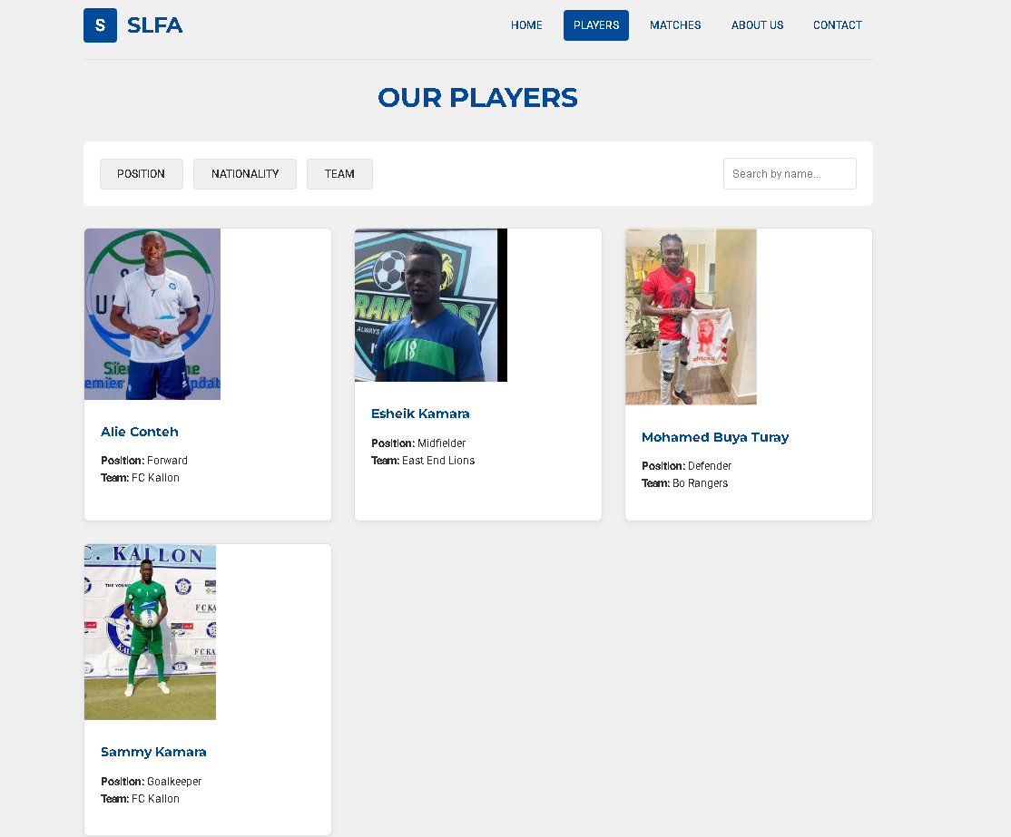

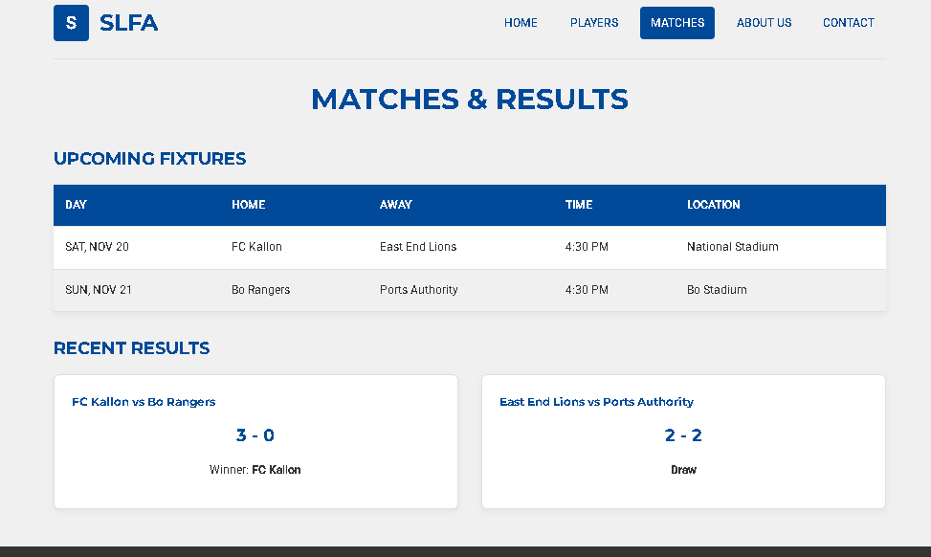

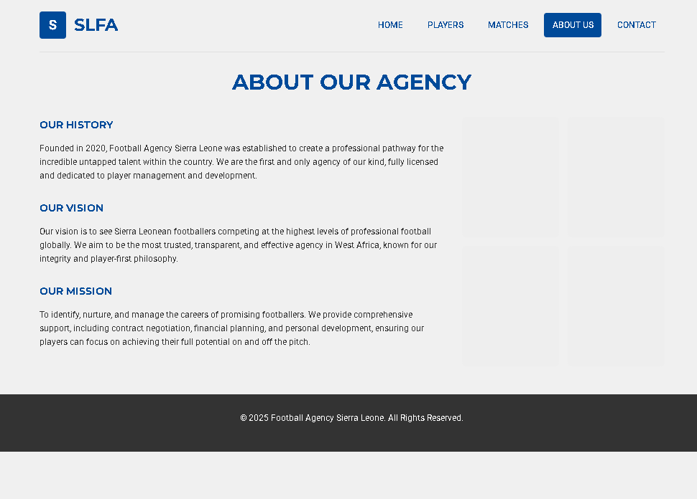

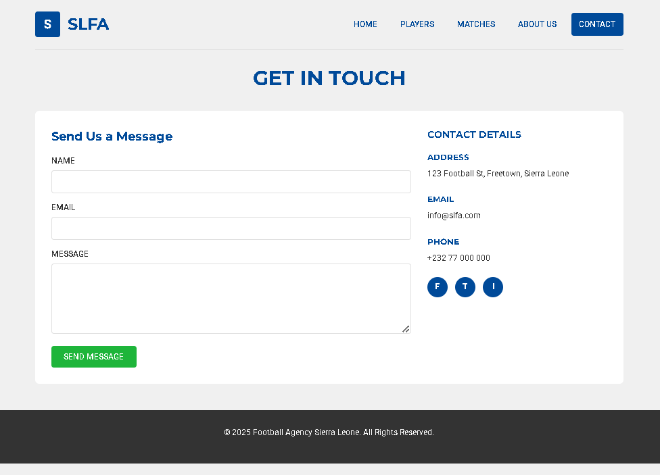

CODE FOR SIERRA LEONE FOOTBALL AGENCY

<!DOCTYPE html>
<html lang="en">
<head>
<meta charset="UTF-8">
<meta name="viewport" content="width=device-width, initial-scale=1.0">
<title>Home - SLFA</title>
<link rel="stylesheet" href="style.css">
<link href="https://fonts.googleapis.com/css2?family=Montserrat:wght@700&family=Roboto:wght@400;500&display=swap" rel="stylesheet">
</head>
<body>
<div class="container">
<header class="site-header">
<div class="logo-area">
<div class="logo-box">S</div>
<h2>SLFA</h2>
</div>
<nav class="main-nav">
<ul>
<li><a href="index.html" class="active">HOME</a></li>
<li><a href="players.html">PLAYERS</a></li>
<li><a href="matches.html">MATCHES</a></li>
<li><a href="about.html">ABOUT US</a></li>
<li><a href="contact.html">CONTACT</a></li>
</ul>
</nav>
</header>

<main>
<h1 class="page-title">HOME PAGE</h1>

<div class="home-layout">
<section class="agency-introduction">
<h2>AGENCY INTRODUCTION</h2>
<p>Welcome to Football Agency Sierra Leone, the nation's premier agency dedicated to managing and promoting local talent. We bridge the gap between promising players and professional opportunities worldwide.</p>
<p>Lorem ipsum dolor sit amet, consectetur adipiscing elit. Sed do eiusmod tempor incididunt ut labore et dolore magna aliqua. Ut enim ad minim veniam, quis nostrud exercitation ullamco laboris nisi ut aliquip ex ea commodo consequat.</p>
<a href="about.html" class="btn">Learn More About Us</a>
</section>

<aside class="news-feed card">
<div class="card-content">
<h3>LATEST NEWS</h3>
<div class="news-item">
<div class="news-item-img"> <img src="international.jpeg"></div>
<div class="news-item-content">
<h4>Local Star Signs with European Club</h4>
<p>2 hours ago</p>
</div>
</div>
<div class="news-item">
<div class="news-item-img"></div>
<div class="news-item-content">
<h4>Upcoming Talent Tryouts Announced</h4>
<p>1 day ago</p>
</div>
</div>
<div class="news-item">
<div class="news-item-img"></div>
<div class="news-item-content">
<h4>SLFA Partners with Premier League</h4>
<p>2 days ago</p>
</div>
</div>
</div>
</aside>
</div>

<section class="highlights-carousel" style="margin-top: 2rem;">
<h2>HIGHLIGHTS</h2>
<div class="grid-container">
<div class="card">
<div class="card-image"> <img src="winnig goal.jpeg" alt=""></div>
<div class="card-content"><h4>Match-Winning Goal</h4></div>
</div>
<div class="card">
<div class="card-image"> <img src="derby.jpeg"></div>
<div class="card-content"><h4>Local Derby Highlights</h4></div>
</div>
<div class="card">
<div class="card-image"><img src="save.jpeg"></div>
<div class="card-content"><h4>Goalkeeper's Best Saves</h4></div>
</div>
</div>
</section>
</main>
</div>

<footer class="site-footer">
<p>&copy; 2025 Football Agency Sierra Leone. All Rights Reserved.</p>
</footer>
</body>
</html>

<!DOCTYPE html>
<html lang="en">
<head>
<meta charset="UTF-8">
<meta name="viewport" content="width=device-width, initial-scale=1.0">
<title>Matches - SLFA</title>
<link rel="stylesheet" href="style.css">
<link href="https://fonts.googleapis.com/css2?family=Montserrat:wght@700&family=Roboto:wght@400;500&display=swap" rel="stylesheet">
</head>
<body>
<div class="container">
<header class="site-header">
<div class="logo-area">
<div class="logo-box">S</div>
<h2>SLFA</h2>
</div>
<nav class="main-nav">
<ul>
<li><a href="index.html">HOME</a></li>
<li><a href="players.html">PLAYERS</a></li>
<li><a href="matches.html" class="active">MATCHES</a></li>
<li><a href="about.html">ABOUT US</a></li>
<li><a href="contact.html">CONTACT</a></li>
</ul>
</nav>
</header>

<main>
<h1 class="page-title">MATCHES & RESULTS</h1>

<section class="matches-table-container">
<h2>UPCOMING FIXTURES</h2>
<table class="matches-table">
<thead>
<tr>
<th>DAY</th>
<th>HOME</th>
<th>AWAY</th>
<th>TIME</th>
<th>LOCATION</th>
</tr>
</thead>
<tbody>
<tr>
<td>SAT, NOV 20</td>
<td>FC Kallon</td>
<td>East End Lions</td>
<td>4:30 PM</td>
<td>National Stadium</td>
</tr>
<tr>
<td>SUN, NOV 21</td>
<td>Bo Rangers</td>
<td>Ports Authority</td>
<td>4:30 PM</td>
<td>Bo Stadium</td>
</tr>
</tbody>
</table>
</section>

<section class="results-section">
<h2>RECENT RESULTS</h2>
<div class="grid-container">
<div class="card">
<div class="card-content">
<h4>FC Kallon vs Bo Rangers</h4>
<h2 style="text-align: center; margin: 1rem 0;">3 - 0</h2>
<p style="text-align: center;">Winner: <strong>FC Kallon</strong></p>
</div>
</div>
<div class="card">
<div class="card-content">
<h4>East End Lions vs Ports Authority</h4>
<h2 style="text-align: center; margin: 1rem 0;">2 - 2</h2>
<p style="text-align: center;"><strong>Draw</strong></p>
</div>
</div>
</div>
</section>
</main>
</div>

<footer class="site-footer">
<p>&copy; 2025 Football Agency Sierra Leone. All Rights Reserved.</p>
</footer>
</body>
</html>

